Chalique nail studio information system



user manual

Itrw 225 project 2017

Analysis paralysis

AY Patel 27342514

RB De klerk 25007335

Nj roberts 25994689

fj verster 25021516

A PRETORIUS 26056569

N PRETORIUS 27532704

Table of Contents

Getting Started 2

System Requirements 3

Installing the software 3

Launching the Installer 3

The Installer 4

Administrator instructions 7

# Getting Started

|  |  |
| --- | --- |
| **Version** | **Comment** |
| Version 1.0 | September 2017: Based on release 1.0 of the Chalique Nail Studio Management System |

**Issue date:** September 2017

**Language:** English (SA)

# System Requirements

|  |  |
| --- | --- |
| OS | Windows 10, Windows 8.1, Windows 8, Windows 7  *64bit Systems only |
| Computer | PC with one of the above OS preinstalled (Upgraded machines not supported).  *.NET Framework 4.5 or later is required. |
| CPU | 1.3GHz core 2 Quad processor or later |
| RAM | Minimum: 512MB  Recommended: 1GB |
| Display | Screen resolution: 1024 x 768 pixels or more  Colour quality: Medium (16 bit or more) |

# Installing the software

## Launching the Installer

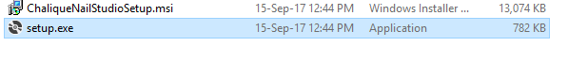

To launch the installer for the Chalique Nail Studio management system, ensure that these files are in a folder on the desktop or on a form of removable media such as a CD or Flash drive to prevent complications.

Open only “setup.exe” to install the system. Ignore the “ChaliqueNailStudio.msi” file as it is only a resource used during installation.

## The Installer

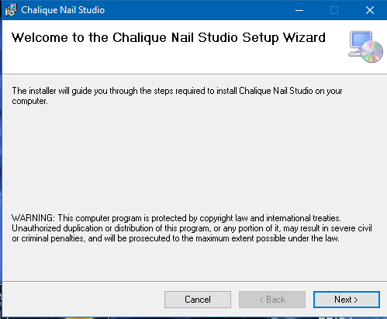

This is the introductory page, click Next to proceed.

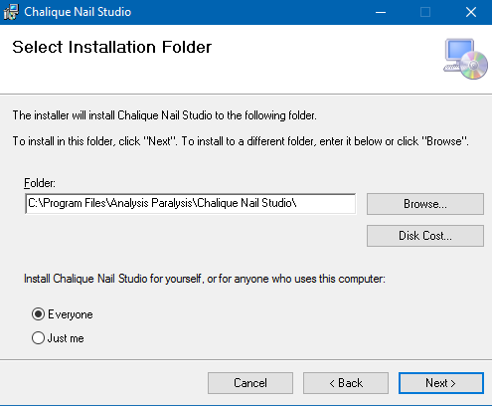

This page can be used to select the installation folder for the system.

Select ‘Everyone’ to prevent access violations in operation of the system.

Click Next to proceed.

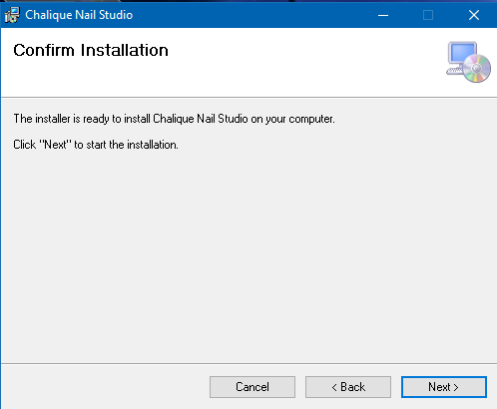

This page confirms that the system is ready for installation. Click Next to proceed, Back to change the installation directory, or Cancel to abort the installation.

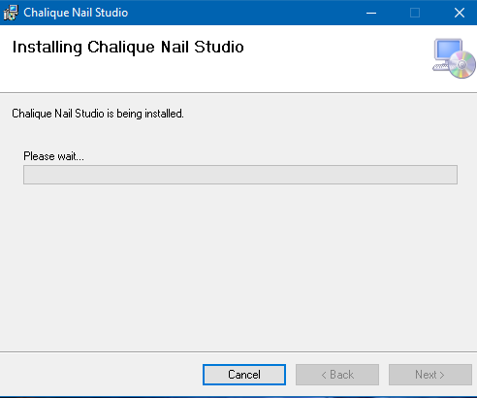 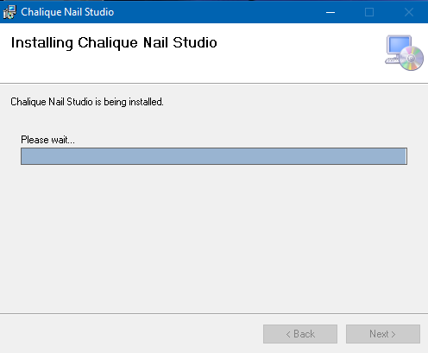

These pages show the progress of installation and the process cannot be cancelled once begun.

After this page, you may receive a prompt to install DotNet 4 or 4.5 which is required for the operation of this system. Accept the installation and follow the prompts to install this.

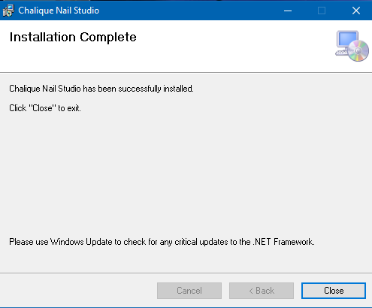

This is the Final form which confirms that the system has been fully installed.

You may now close the installation wizard and remove the CD or Flash drive if any were used in the installation.

# Administrator instructions

The administrator has all the permissions and access level of an owner of the system.

The administrator is in charge of maintaining the system in case of serious faults or data corruption in the system.

If the database cannot be found, a copy of the database can be found on the installation CD, or the backup can be restored to the folder “ %USER%\\AppData\\Roaming\\Chalique Nail Studio\\ “ and renamed to “ChaliqueNailStudio.accdb” with no other extensions.

The administrator username is “admin” with password “admin”

All source code and the original Solution for Visual Studio has been included with the installation CD in case of required maintenance and future system upgrades.